How to successfully begin your IEEE WebEx session (Visual and audio):

Note: Intercall Conferencing Toll-Free Help Line and an IEEE WebEx Conferencing help guide are located at the end. Please do not hesitate to reach out to an Intercall Support Representative if you are experiencing technical difficulties. At the bottom of this document, you will find the Reservationless-Plus User Guide (Keypad Commands), which may be used (during the conference) to assist you with getting an Intercall representative on the line, as well as useful shortcuts to make changes to your conference.

There are a few easy steps to this process, and the order of these steps must be followed to replicate success each time.

Step 1: Click on the WebEx meeting link. This link is provided to you once your requested meeting has been created. The link will look similar to this: https://ieeemeetings.webex.com/ieeemeetings/j.php?ED=#########&UID=#########&RT=MiMxMQ%3D%3D

Step 2: You will have to join the meeting as a participant. (Your webex session will not be available to open until at least 15 minutes before scheduled starting time.) You will be asked for your name and email address.
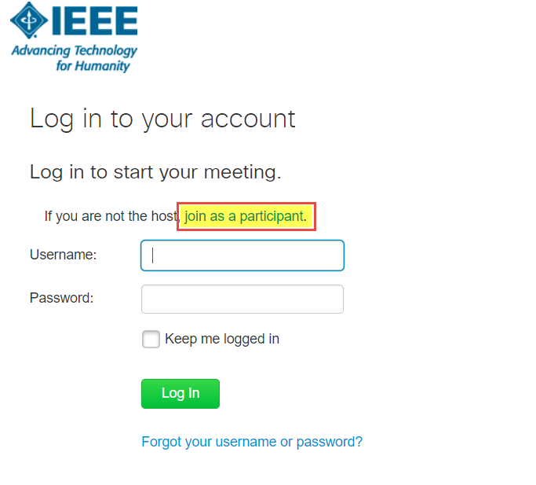

Step 3: Fill in the information and click “Join.”

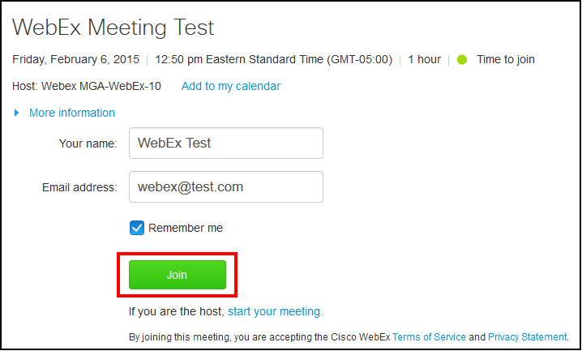

Step 4: The WebEx application will launch, and you will be notified that the host has not yet joined the meeting. Click on OK.

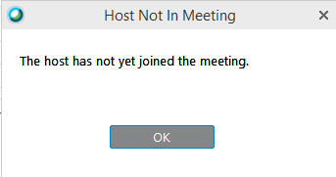

Step 5: Click on “Participant” from the menu bar on the top left of the screen, then select “Reclaim Host Role.”
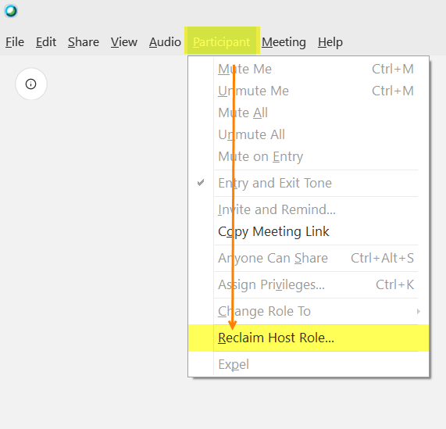

Step 6: A window will open, and will prompt you for the host code. If you are the meeting requester, you will have been given this code.

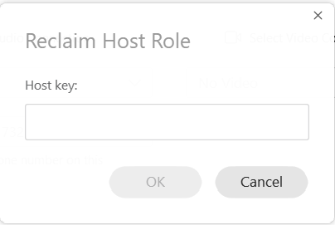

Step 7: Once you’ve reclaimed the host role, your name will then have “(Host)” written next to it, in the ‘participants’ window.

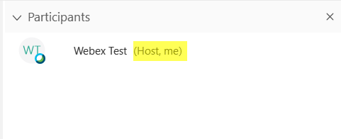

Step 8:
The System will prompt you to make a “Audio and Video Connection” when you enter the Webex. If it does not, you can open it using the upper left navigation links. Please make sure that you select your audio device to either call in or use your computer.

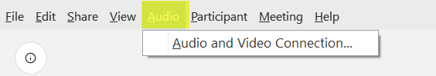

Step 8a: To start a call (Using a telephone):

- Dial the appropriate number shown in the Audio and Video connection box. (US Toll Free or
Global Call-In Numbers)
- Enter your access code followed by #.
- Enter your Attendee ID followed by a #.

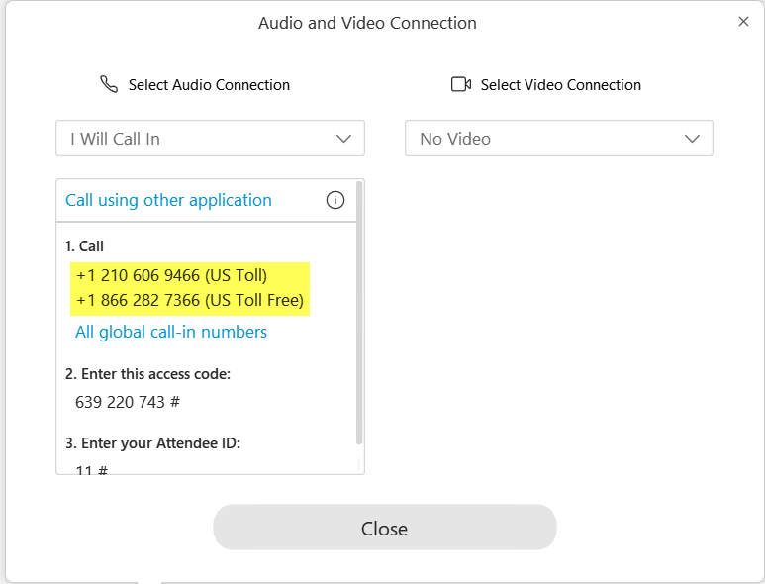
Step 8b: To start a call (Using your Computer): To join the audio using your computer speakers and microphone, click on “Audio and Video Connection” on the main WebEx screen. Using the dropdown select “Call Using Computer” WebEx will ask you to make selections so that you are able to hear your attendees, and they will be able to hear you.

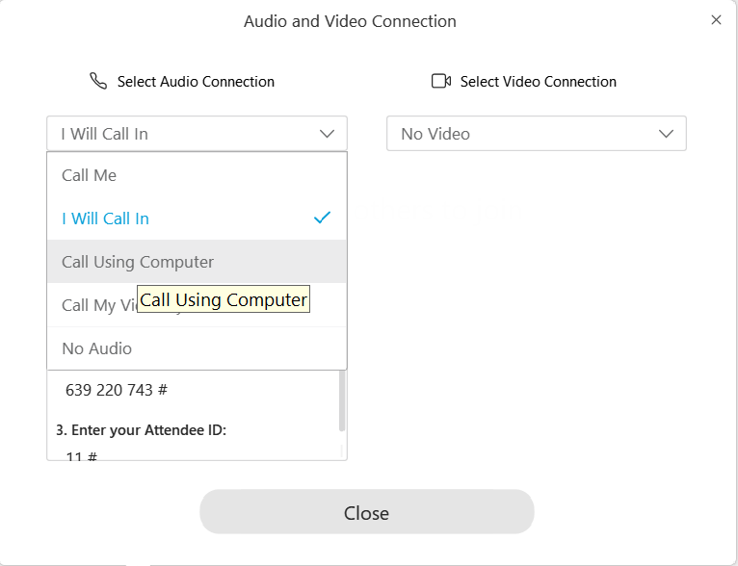

Select the appropriate Speaker device from the drop down Menu.

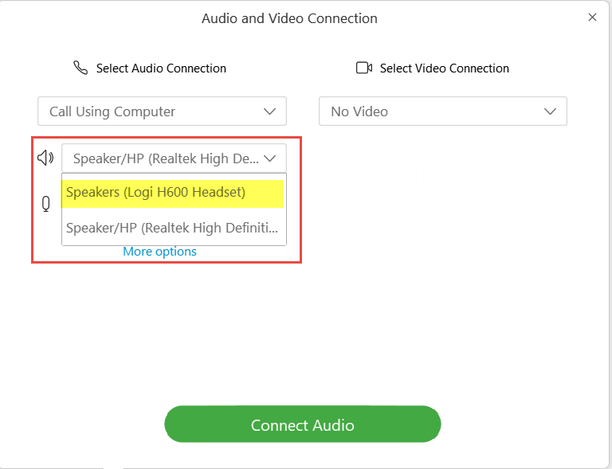
Note: You will only have more than one Option if you have multiple speaker devices plugged
into your PC.

Next, you will have to select your Microphone Device. Again, you will only have more than one option given if you have more than one microphone device plugged into your PC

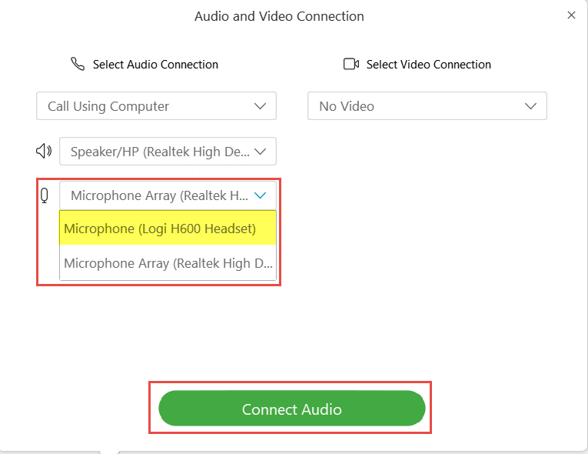

Click ‘Connect Audio.’

Step 9: Change Presenter Role

When you Reclaim Host Role, you will automatically be shown as the Presenter. To view, click on the Participants Icon.

When the Participants Window is opened, you will see a Globe next to the Presenters name.

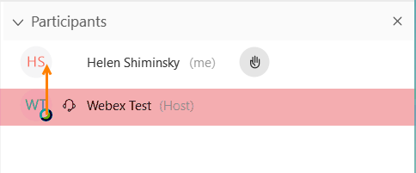

To change the presenter, drag the Globe from your/the presenters name to the new presenter.
You will then be prompted to confirm this change. Select “Yes”
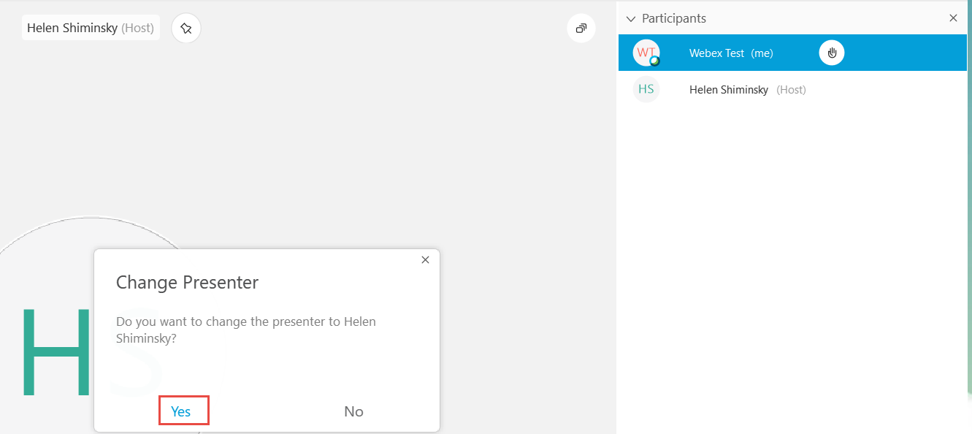

Step 10:
To Share your Content/Screens, etc. Select the “Share Content” icon in the bottom center icon list. It shows as an arrow pointing up with an underline.

The Share Content Screen selection will appear. You can choose to select a specific Screen or Program. Once chosen, that screen or program will open.

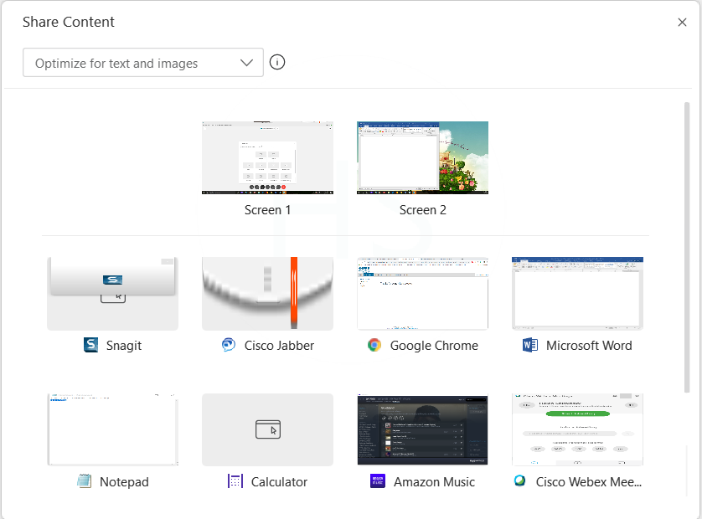
You can choose to stop sharing your screen at any time using the floating top bar.

Step 11: Record your meeting

From the floating bar you can also select to start recording your meeting.

Step 11a:
To start recording, select Recorder
It will show “Record in Cloud” – Click on the red Record button

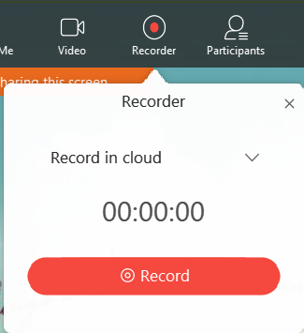

Step 11b:
Pause or Stop the recording at any time by selecting the Recorder button again. If you stop and then restart the meeting, it will record as two separate files. Use pause to maintain one file.

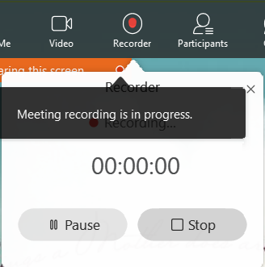
Once the meeting has ended, contact IEEE staff to obtain a link for your webex recording. We will then provide you with the information as soon as it is made available.

Intercall Support Information:

If you are experiencing issues during the conference, please use these keypad commands to receive assistance from Intercall support representatives:

Reservationless-Plus User Guide (Keypad Commands)
http://sites.ieee.org/vtools/documents/2014/03/resplus-userguide-2014.pdf

For support contact information and FAQs:
ResPlus and Web Support -- IEEE Specific Questions | Toll-Free Help Line | Email Contact
Dedicated IEEE Support | 866.251.9110 | ieeesupport@intercall.com

